**RedHat Linux 7安装CentOS 7 yum源**

**MyRedHat**

1. PackageKit-yum-1.1.5-1.el7.x86\_64
2. yum-utils-1.1.31-42.el7.noarch
3. yum-langpacks-0.4.2-7.el7.noarch
4. yum-rhn-plugin-2.0.1-9.el7.noarch
5. yum-metadata-parser-1.1.4-10.el7.x86\_64
6. yum-3.4.3-154.el7.noarch

由于[Red Hat](http://www.linuxidc.com/topicnews.aspx?tid=10" \t "_blank" \o "Red Hat) Enterprise Linux 7 的更新包只对注册的用户生效，所以需要自己手动更改成[CentOS](http://www.linuxidc.com/topicnews.aspx?tid=14" \o "CentOS" \t "_blank) 的更新包，CentOS几乎和[RedHat](http://www.linuxidc.com/topicnews.aspx?tid=10" \o "RedHat" \t "_blank)是一样的，所以无需担心软件包是否可安装，下面是安装步骤。

1、首先查看redhat 7.0系统本身所安装的那些yum 软件包：  
[root@linuxidc ~]# rpm -qa | grep yum  
yum-utils-1.1.31-24.el7.noarch  
yum-langpacks-0.4.2-3.el7.noarch  
yum-metadata-parser-1.1.4-10.el7.x86\_64  
yum-rhn-plugin-2.0.1-4.el7.noarch  
PackageKit-yum-0.8.9-11.el7.x86\_64  
yum-3.4.3-118.el7.noarch

2、卸载这些软件包；  
[root@linuxidc ~]# rpm -e yum-3.4.3-118.el7.noarch --nodeps  
[root@linuxidc ~]# rpm -e yum-utils-1.1.31-24.el7.noarch --nodeps  
[root@linuxidc ~]# rpm -e yum-rhn-plugin-2.0.1-4.el7.noarch --nodeps  
[root@linuxidc ~]# rpm -e yum-metadata-parser-1.1.4-10.el7.x86\_64 --nodeps  
[root@linuxidc ~]# rpm -e yum-langpacks-0.4.2-3.el7.noarch --nodeps  
[root@linuxidc ~]# rpm -e PackageKit-yum-0.8.9-11.el7.x86\_64 --nodeps

3、保证本机电脑能上网；  
[root@linuxidc ~]# ping www.baidu.com  
PING www.a.shifen.com (163.177.151.110) 56(84) bytes of data.  
bytes from 163.177.151.110: icmp\_seq=1 ttl=49 time=13.1 ms  
bytes from 163.177.151.110: icmp\_seq=2 ttl=49 time=6.80 ms  
bytes from 163.177.151.110: icmp\_seq=3 ttl=49 time=6.77 ms  
^C  
--- www.a.shifen.com ping statistics ---  
packets transmitted, 3 received, 0% packet loss, time 2007ms  
rtt min/avg/max/mdev = 6.777/8.917/13.168/3.006 ms

4、进入以下网站上面查看软件包的版本是否升级或者找到自己系统所对应的文件包版本更新；  
网易163网络源地址：http://mirrors.163.com/  
CentOS网络源地址：<http://centos.ustc.edu.cn/centos/>

http://mirrors.163.com/centos/7/os/x86\_64/Packages/

5、找到自己所需要的版本下载：  
wget http://mirrors.163.com/centos/7/os/x86\_64/Packages/yum-3.4.3-150.el7.centos.noarch.rpm  
wget http://mirrors.163.com/centos/7/os/x86\_64/Packages/yum-metadata-parser-1.1.4-10.el7.x86\_64.rpm  
wget http://mirrors.163.com/centos/7/os/x86\_64/Packages/yum-utils-1.1.31-40.el7.noarch.rpm  
wget http://mirrors.163.com/centos/7/os/x86\_64/Packages/yum-updateonboot-1.1.31-40.el7.noarch.rpm  
wget http://mirrors.163.com/centos/7/os/x86\_64/Packages/yum-plugin-fastestmirror-1.1.31-40.el7.noarch.rpm

6、查看下载完成结果；  
[root@linuxidc ~]# ls  
anaconda-ks.cfg                              yum-plugin-fastestmirror-1.1.31-40.el7.noarch.rpm  
initial-setup-ks.cfg                        yum-updateonboot-1.1.31-40.el7.noarch.rpm  
yum-3.4.3-150.el7.centos.noarch.rpm          yum-utils-1.1.31-40.el7.noarch.rpm  
yum-metadata-parser-1.1.4-10.el7.x86\_64.rpm

7、安装软件包：  
[root@linuxidc ~]# rpm -ivh yum-\*  
warning: yum-3.4.3-150.el7.centos.noarch.rpm: Header V3 RSA/SHA256 Signature, key ID f4a80eb5: NOKEY  
error: Failed dependencies:  
        python-urlgrabber >= 3.10-8 is needed by yum-3.4.3-150.el7.centos.noarch

这里出现了一个小问题~~~：安装的python-urlgrabber版本不符合您尝试安装的RPM的依赖关系，我目前没有能力解决这个问题的办法，  
后来想了一个折中的办法，FQ去一个国外的yum源网站下载上面这五个较低版本的安装包，在来安装就不会有问题了  
在这里附上链接各位可以FQ出去下载对应版本的rpm包  
    链接：http://rpm.pbone.net/  
    不报错版本安装包：  
yum-3.4.3-132.el7.centos.0.1.noarch.rpm  
yum-metadata-parser-1.1.4-10.el7.x86\_64.rpm  
yum-plugin-fastestmirror-1.1.31-34.el7.noarch.rpm  
yum-updateonboot-1.1.31-34.el7.noarch.rpm  
yum-utils-1.1.31-34.el7.noarch.rpm

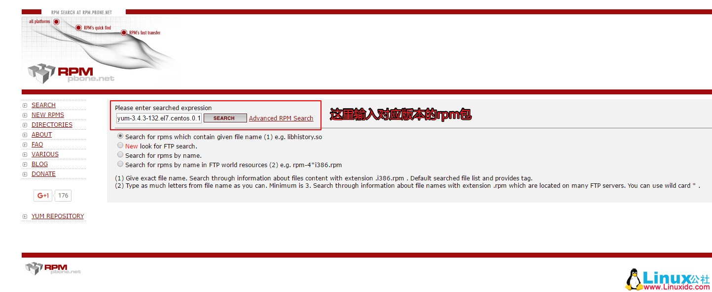

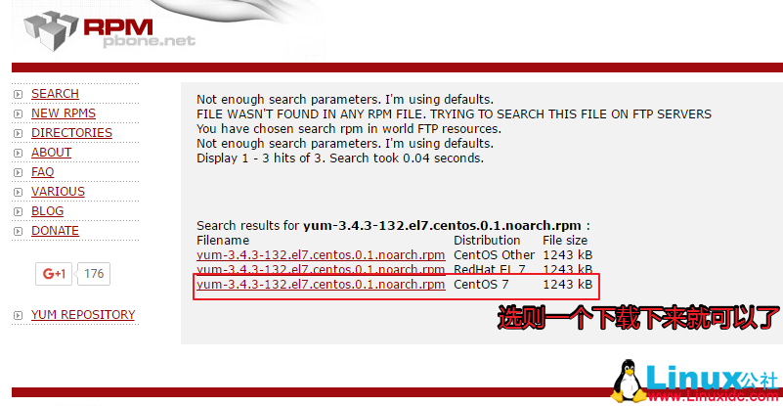

我把这五个rpm包下载到我的Windows电脑里，然后用WinSCP这个软件上传到redhat 7 系统里，WinSCP这个软件的使用方法就不在这里赘述了

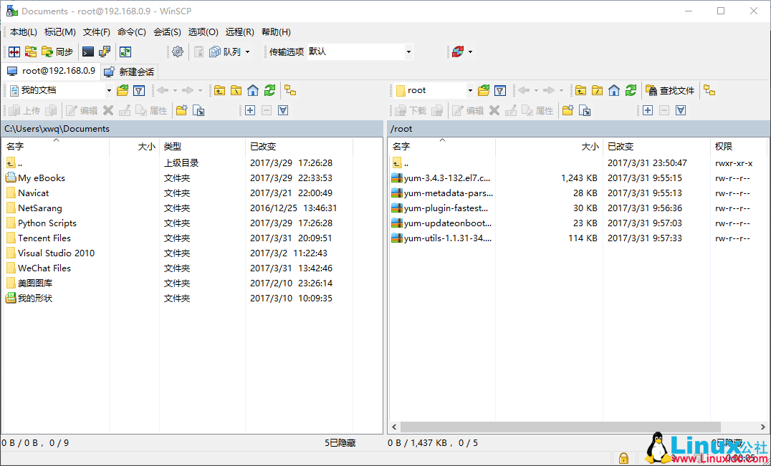

8、下载好后重新安装：  
[root@linuxidc ~]# ls

1. yum-3.4.3-132.el7.centos.0.1.noarch.rpm
2. yum-updateonboot-1.1.31-34.el7.noarch.rpm
3. yum-metadata-parser-1.1.4-10.el7.x86\_64.rpm
4. yum-utils-1.1.31-34.el7.noarch.rpm
5. yum-plugin-fastestmirror-1.1.31-34.el7.noarch.rpm

[root@linuxidc ~]# rpm -ivh yum-\*  
warning: yum-3.4.3-132.el7.centos.0.1.noarch.rpm: Header V3 RSA/SHA256 Signature, key ID f4a80eb5: NOKEY  
Preparing...                          ################################# [100%]  
Updating / installing...  
  1:yum-metadata-parser-1.1.4-10.el7 ################################# [ 20%]  
  2:yum-plugin-fastestmirror-1.1.31-3################################# [ 40%]  
  3:yum-3.4.3-132.el7.centos.0.1    ################################# [ 60%]  
  4:yum-updateonboot-1.1.31-34.el7  ################################# [ 80%]  
  5:yum-utils-1.1.31-34.el7          ################################# [100%]  
[root@linuxidc ~]#  
这次没有报错了，安装完成！！！

9、新建repo 配置文件；

[root@linuxidc ~]# vim /etc/yum.repos.d/CentOS-Base.repo

#CentOS-Base.repo  
#  
# The mirror system uses the connecting IP address of the client and the  
# update status of each mirror to pick mirrors that are updated to and  
# geographically close to the client.  You should use this for CentOS updates  
# unless you are manually picking other mirrors.  
#  
# If the mirrorlist= does not work for you, as a fall back you can try the  
# remarked out baseurl= line instead.  
#  
#  
[base]  
name=CentOS-$7 - Base - 163.com  
#mirrorlist=http://mirrorlist.centos.org/?release=$7&arch=$basearch&repo=os  
baseurl=http://mirrors.163.com/centos/7/os/$basearch/  
gpgcheck=1  
gpgkey=http://mirrors.163.com/centos/RPM-GPG-KEY-CentOS-7

#released updates  
[updates]  
name=CentOS-$7 - Updates - 163.com  
#mirrorlist=http://mirrorlist.centos.org/?release=$7&arch=$basearch&repo=updates  
baseurl=http://mirrors.163.com/centos/7/updates/$basearch/  
gpgcheck=1  
gpgkey=http://mirrors.163.com/centos/RPM-GPG-KEY-CentOS-7

#additional packages that may be useful  
[extras]  
name=CentOS-$7 - Extras - 163.com  
#mirrorlist=http://mirrorlist.centos.org/?release=$7&arch=$basearch&repo=extras  
baseurl=http://mirrors.163.com/centos/7/extras/$basearch/  
gpgcheck=1  
gpgkey=http://mirrors.163.com/centos/RPM-GPG-KEY-CentOS-7

#additional packages that extend functionality of existing packages  
[centosplus]  
name=CentOS-$7 - Plus - 163.com  
baseurl=http://mirrors.163.com/centos/7/centosplus/$basearch/  
gpgcheck=1  
enabled=0  
gpgkey=http://mirrors.163.com/centos/RPM-GPG-KEY-CentOS-7

10、清除缓存：

[root@linuxidc ~]# yum clean all  
Loaded plugins: fastestmirror, product-id, subscription-manager  
This system is not registered to Red Hat Subscription Management. You can use subscription-manager to register.  
Cleaning repos: base extras updates  
Cleaning up everything

11、测试安装是否正常；

[root@linuxidc ~]# yum -y install lftp  
Loaded plugins: fastestmirror, product-id, subscription-manager  
This system is not registered to Red Hat Subscription Management. You can use subscription-manager to register.  
base                                                                                            | 3.6 kB  00:00:00      
extras                                                                                          | 3.4 kB  00:00:00      
updates                                                                                        | 3.4 kB  00:00:00      
(1/4): extras/x86\_64/primary\_db                                                                | 139 kB  00:00:00      
(2/4): base/x86\_64/group\_gz                                                                    | 155 kB  00:00:00      
(3/4): updates/x86\_64/primary\_db                                                                | 3.9 MB  00:00:01      
(4/4): base/x86\_64/primary\_db                                                                  | 5.6 MB  00:00:02      
Determining fastest mirrors  
Resolving Dependencies  
--> Running transaction check  
---> Package lftp.x86\_64 0:4.4.8-8.el7\_3.2 will be installed  
--> Finished Dependency Resolution

Dependencies Resolved

=======================================================================================================================  
Package                Arch                      Version                            Repository                  Size  
=======================================================================================================================  
Installing:  
lftp                    x86\_64                    4.4.8-8.el7\_3.2                    updates                    751 k

Transaction Summary  
=======================================================================================================================  
Install  1 Package

~~~~~此处省略安装输出内容~~~~  
Installed:  
  lftp.x86\_64 0:4.4.8-8.el7\_3.2

Complete!

到这里安装完成，以后安装所需包，可以不用本地yum源了，直接使用网络yum源。